National University of Computer and Emerging Sciences



Lab Manual

for

Object Oriented Programming

|  |  |
| --- | --- |
| Course Instructor | Dr. Saira Karim |
| Lab Instructor(s) | Ms. Sonia Anum  Ms. Mamoona Akbar |
| Section | OOP BSCS-2A |
| Semester | Spring 2022 |

Department of Computer Science

FAST-NU, Lahore, Pakistan

Lab Manual 5

**Objectives:**

After performing this lab, students shall be able to:

* Dynamic 2D arrays, allocation and deallocation.
* Classes, getters, setters and constructors

**Problem 1**

Write a function called rotateOuterLayerBy1, which takes a 2 dimensional square matrix and its dimension, n, as parameters and rotate the outermost layer by one place, anti-clockwise. Use 2D pointers to create and access the two dimensional array.

**Constraint:** Your code cannot create an extra array to accomplish the given task. But you can create one or two extra integers.

**Example:**

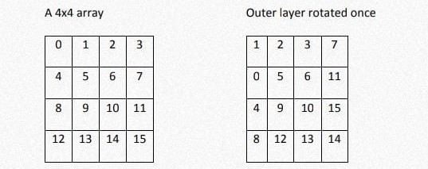

**Problem 2**

A boy has his money deposited $1000, $1500 and $2000 in banks-Bank A, Bank B and Bank C respectively. We have to print the money deposited by him in a particular bank.  
Create a class 'Bank' with a function 'getBalance' which returns 0. Make its three subclasses named 'BankA', 'BankB' and 'BankC' with a function with the same name 'getBalance' which returns the amount deposited in that particular bank. Call the function 'getBalance' by the object of each of the three banks.

**Problem 3**

Create a class named 'Rectangle' with two data members- length and breadth and a function to calculate the area which is 'length*breadth'. The class has three constructors which are :  
1 - having no parameter - values of both length and breadth are assigned zero.  
2 - having two numbers as parameters - the two numbers are assigned as length and breadth respectively.  
3 - having one number as parameter - both length and breadth are assigned that number.  
Now, create objects of the 'Rectangle' class having none, one and two parameters and print their areas.